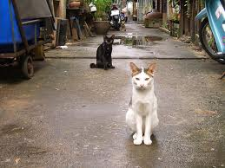

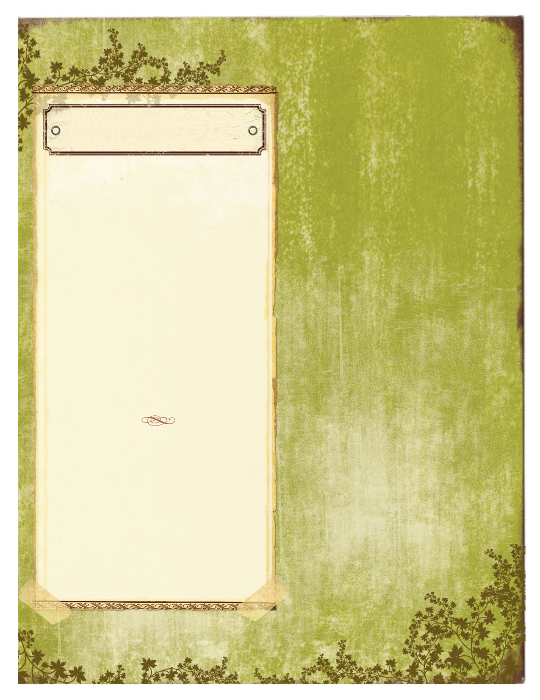
In 1970 over 20 million animals were being euthanized every year. Currently in the U.S. less than 4 million cats and dogs are euthanized each year .The methods of euthanizations have failed to reduce numbers or educate the public in any way. In the past 30 years these tactics of rounding up animals and killing them has not reduced populations in any way. In fact the methods used for the process have been largely disputed and frowned upon by the younger generation and in fact over 79% of young adults do not support this method. The cost to taxpayers of catching, warehousing, euthanizations and disposal of the body is $2 billion dollars per year (Manning, 2012). If this issue is not resolved we will continue to destroy innocent animals at the expense of your tax dollars. Since 2001 there has been remarkable change all over this country from implementing community education programs, low or no cost spay and neuter programs and finally TNR (Trap Neuter Return) programs. For every dollar spent on these programs, $19 is saved per animal substantially reducing the cost to taxpayers. The number of pets euthanized and cost to citizens has dramatically been reduced by implementing TNR programs.

Feral cats can never be owned as pets. A feral cat simply means it was not socialized at a young age. It does not mean it cannot become socialized. The problem with trapping, housing and killing cats is that typically because of cats traits owners do not go looking for an outside cat right away, cats are not licensed or leashed the way dogs are therefore there are many cats who are not sick, feral or un-owned that are euthanized. Laws were made in the 1930’s to license and vaccinate dogs, due to rabies outbreaks. Animal control was formed to enforce and regulate the population it was never intended to house, trap and kill felines. In fact in most cities there are no laws or requirements for animals control to trap cats (Boks, 2005)

Statistically more people take in or feed feral cats that become owned cats than any other type of animal. If a cat is spayed or neutered and vaccinated that cat statistically will live as long as an indoor cat. There are people ready and willing to help feed and care for community cats. These cats reduce the numbers of pests and with community education help the community to function as a team and educate the public on proper care for community cats as well as owned pets.
newsletter text here. Continue newsletter text here. Continue newsletter text here. Continue newsletter text here. Continue newsletter text here. Continue newsletter text here. Continue newsletter text here. Continue newsletter text here.

“The greatness of a nation and its moral progress can be judged by the way its animals are treated.”
~Mahatma Gandhi

Cats Plight in Our Society
Supporting TNR

October 5, 2013

VOL. #1 ISSUE #1
A local shelter does not have time to find homes or keep animals, the “No Kill” status turns animals away to be abandoned on the streets. The programs that have been implemented have taken county funded animal shelters from a 74% kill rate down to 24% (New York City, 2012). A fact that may surprise some is that, nationwide, cats comprise close to 70% of the animals dying in shelters and most of those are free-roaming (stray or feral) community cats. In order to achieve no-kill, we must institutionalize TNR as the accepted management protocol for community cats at the municipal level. Frightened or fractious cats never make it to the adoption room. They have no business entering a shelter in the first place. Through networking, volunteering, rescue and most importantly foster programs this actually reduces the work for shelter employees and implements real solutions to controlling pet populations.

.

Is it more effective to trap and euthanize cats, is it more humane? Trapping a cat and releasing it back to the elements is a “slow kill” and suffering to the cat.
Statistically more people take in or feed feral cats that become owned cats than any other type of animal. If a cat is spayed or neutered and vaccinated that cat statistically will live as long as an indoor cat. There are people ready and willing to help feed and care for community cats. These cats reduce the numbers of pests and with community education help the community to function as a team and educate the public on proper care for community cats as well as owned pets.

Helping
These cats are a nuisance and create problems in the community. The behaviors that are typically problematic are cat fighting due to territory or mating, spraying or marking territory and feces in garden or yard areas. Through proper knowledge on the subject it is a fact that by spaying and neutering a cat there is a 95% reduction in these behaviors. Cats are more relaxed and overall healthier, able to maintain higher body weight and spread fewer diseases to one another once fixed (Best Friends, 2010).
There are natural deterrents that cats do not like such as clear rubber mats with the spikes pointing up, or mulch they do not like the feel on their feet. One might plant curry or lavender as they do not tolerate the smell. There are other plants and spices that will deter cats from coming into the area while being humane and promoting kindness and compassion.

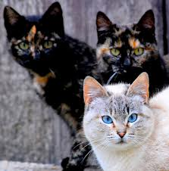

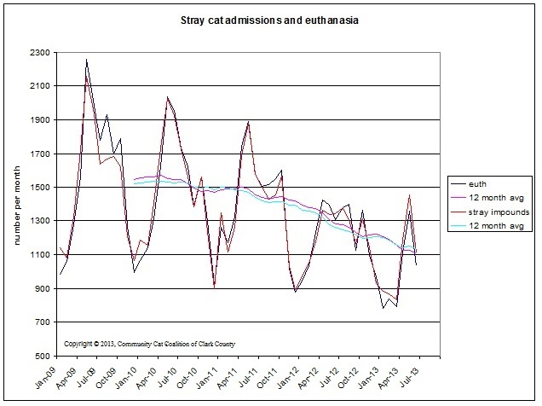
Works Cited
People don’t have the time or money to save all these cats. It actually costs far less money to help these cats. There are programs easily accessible all over the country to help assist with feral cats, there is even information for people who want to start programs in their area. These programs are typically non-profit and low cost to citizens because most money is thru donations, grants and sponsorships. The mass killing of felines is an old way of thinking and it does not work! It is time for change, take what we have learned and move forward by helping these animals as the old ways have not worked. For true population-control solutions there must include public education to increase awareness of free-roaming cat issues and impacts. Low-cost spay neuter programs for owned cats would complement free-roaming cat management by reducing the probability that owned cats will serve as source populations, thus negating control attempts.
In conclusion by implementing programs to educate and address the community cat issue in our community we create a stronger community for ourselves and our animal companions. It is a fact that in communities where they implement programs such as these populations are controlled, personal pets are taken better care of and the community is ready to address and conquer other endeavors such as community gardens, volunteer projects, clean up, recycling, helping the homeless and many other efforts that improve our quality of life as well as educate future generations how to be accountable and compassionate.

“The greatness of a nation and its moral progress can be judged by the way its animals are treated.”
~Mahatma Gandhi

Continue newsletter text here. Continue newsletter text here. Continue newsletter text here. Continue newsletter text here. Continue newsletter text here. Continue newsletter text here. Continue newsletter text here. Continue newsletter text here. Continue newsletter text here. Continue newsletter text here. Continue newsletter text here. Continue newsletter text here. Continue newsletter text here. Continue newsletter text here. Continue newsletter text here. Continue newsletter text here. Continue newsletter text here. Continue newsletter text here Continue newsletter text here

Continue newsletter text here. Continue newsletter text here. Continue newsletter text here. Continue newsletter text here. Continue newsletter text here. Continue newsletter text here. Continue newsletter text here. Continue newsletter text here. Continue newsletter text here.

Continue newsletter text here. Continue newsletter text here. Continue newsletter text here. Continue newsletter text here. Continue newsletter text here. Continue newsletter text here. Continue newsletter text here. Continue newsletter text here. Continue newsletter text here. Continue newsletter text here. Continue newsletter text here. Continue newsletter text here.

Continue newsletter text here. Continue newsletter text here. Continue newsletter text here. Continue newsletter text here. Continue newsletter text here. Continue newsletter text here.

Continue newsletter text here. Continue newsletter text here. Continue newsletter text here. Continue newsletter text here. Continue newsletter text here. Continue newsletter text here. Continue newsletter text here. Continue newsletter text here.

Continue newsletter text here. Continue newsletter text here. Continue newsletter text here. Continue newsletter text here. Continue newsletter text here. Continue newsletter text here. Continue newsletter text here. Continue newsletter text here. Continue newsletter text here.

"Best Friends Animal Society." Best Friends Animal Society. N.p., n.d. Web. 05 Oct. 2013.
Boks, Ed. "Saving Man's Best Friends." USA Today (Farmingdale) Vol. 134, No. 2726 Nov. 2005: pg 32-33. Web. 5 Oct. 2013. <http://sks.sirs.com>.
C5 “Community Cat Coalition of Clark County” copyright 2013. Unknown author. http://www.c5-tnr.org/keeping-score.php
Jouvenal, Justin. "Fight Over Ferals Asks: Is an Alley Cat's Life Worth Living?" Washington Post 2011 may 25: A.1. Web. 5 Oct. 2013. <http://sks.sirs.com>.
Manning, Sue. "Euthanasia to Control Shelter Population Unpopular." Newsday 2012 Jan 05: N.p. Web. 5 Oct. 2013. <http://sks.sirs.com>.
Mcgraw, Carol. "Volunteers Cage Cats to Deliver to Humane Society." Gazette-Mail 2010 Sept 26: A.15. Web. 5 Oct. 2013. <http://sks.sirs.com>.

